
Behaviour policy
Matlock & Dales Primary Partnership
Review: Annually

Version | Date | Narrative | Minute No. | Review Date
1 |  | NEW! Revised policy following training:  - at the HT Network;  - DDAT Training Conference;  - Staff training;  - TA Forum;  - MDS training.
2 | September 2025 | Revised to clarify:  - Timings for sanctions
3 | July 2025 | Revised to incorporate CPOMS and reporting positive points to parents | AS/LTC/2526/300925/9  BAK/LTC/2526/081025/11 STG/LTC/2526/011025/10  DCT/LTC/2526/021025/10 | September 2026
4 | June 2026 | Revised to reflect Dfe’s and Trust guidance and policy on restrictive intervention  - Section 1  - Section 5: Included positive support and de-escalation  - Section 8: questions staff should consider before use of restrictive intervention.

Contents
1. Introduction 3
2. Principles of our approach to behaviour 5
3. Six stages of crises 6
4. Regulate, Relate, Reason 7
5. Positive support and de-escalation 8
6. Our agreed school rules 9
7. Recognition, celebration and appreciation 14
8. Responding to behaviour incidents in a relational way 18
9. Our graduated approach to behaviour 19
Appendix 2: Restorative Discussion: Listen, Link, Learn 25
Appendix 3: What happens when a child is unable to regulate their emotions or behaviour. 26

1. Introduction
All of the schools in the Matlock and Dales Primary Partnership (All Saints CE Infants, All Saints CE Junior, Bakewell CE Infants, Darley Churchtown CE Primary and St. Giles CE Primary) believe in creating a safe and nurturing environment which supports the emotional well-being and development of every child so that all benefit from ‘life in all its fullness’.

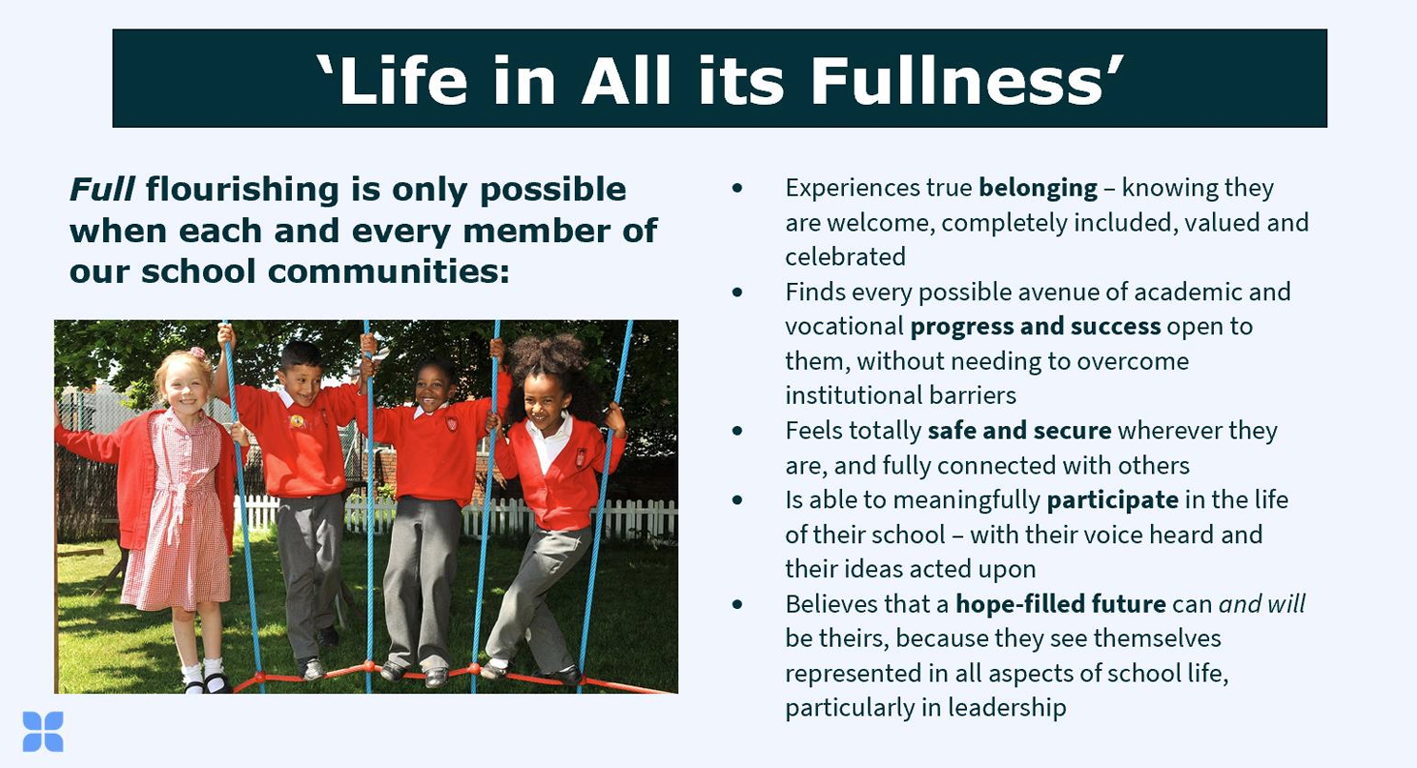
Figure 1: Flourishing for all (September 2024)

Each school within the Matlock and Dales Primary Partnership is a Church of England school, committed to putting Christian values at the centre of all that we do. We are a family and shared values are important. Each school and all staff have the highest expectations of conduct. We believe:
- in the importance of good manners
- in treating others with care and respect at all times, both in and outside of the classroom and throughout the school day.
This policy will support staff in each school to have consistent, positive and purposeful school-wide practices. Each school’s distinctively Christian vision promotes and recognises this:
- All Saints’ CE Infant: Family, faith, flourish
- All Saints’ CE Junior: Family, faith, flourish
- Bakewell CE Infant: Be the light for others, so they will see God in the good things you do
- Darley Churchtown CE Primary: Aim high and believe, grow and succeed
- St. Giles CE Primary: Let us run the race before us and never give up

This policy is to be read in conjunction with:
- Restrictive Intervention policy (DDAT);
- SEND policy (DDAT adapted for the partnership)
- Use of restrictive interventions... in school (Dfe: April 2026)

2. Principles of our approach to behaviour
Our practice is aligned with research and theory from the fields of behavior, emotional support and attachment. These approaches are based around several core principles including:

All behaviour is a form of communication.
Emotions matter to learning.

- Positive Relationships: We prioritise building positive relationships between children, staff and families. We aim to create a secure base for every child, where they feel valued, respected and supported. By fostering a sense of belonging and trust, we can create equitable environments where all children, including those with additional needs, can develop healthy attachments.
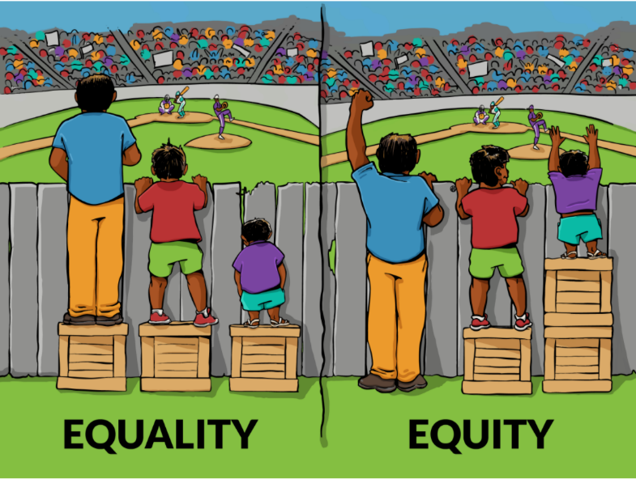

- Teaching: We understand that our job as educators is to help all children develop the skills to make safe behaviour choices. Whilst we challenge and address errors in behaviour, we also teach our children how to behave respectfully.
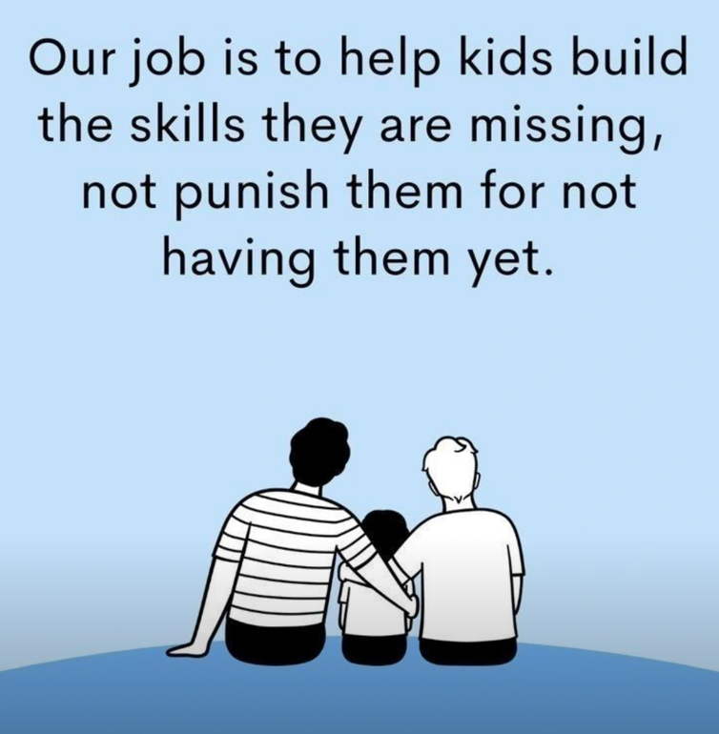

- Emotional Regulation: We understand that children who have experienced trauma may struggle with emotional regulation. Our staff are trained to recognise signs of distress and respond appropriately. We provide tools and strategies to help children manage their emotions effectively, enabling greater self- regulation and resilience.

- Sensory Considerations: We recognise that sensory experiences can significantly impact a child's behavior and well-being. Our classrooms and learning spaces are designed to be sensory-friendly, considering factors such as lighting, noise levels, and visual stimuli. We provide sensory breaks and calming areas where children can regulate their sensory input.

- Social-Emotional Learning: We incorporate social-emotional learning into our curriculum (based upon research from the Education Endowment Foundation 2021) to support the development of empathy, self-awareness, and positive relationships. Through activities such as planned Circle Time, discussions, and adult role modelling, we help children develop essential social and emotional skills which positively contribute to their overall well-being and behaviour.

3. Six stages of crises

As humans, we are state-dependent. This means that our brain and body react depending on our emotional and physiological state.
When we are in a calm and relaxed state, the brain allows us to think clearly and make rational decisions. However, when we feel anxious, actions become reactive and our brain prioritises protective measures rather than thinking clearly and reasoning logically. This is set out in the model below:

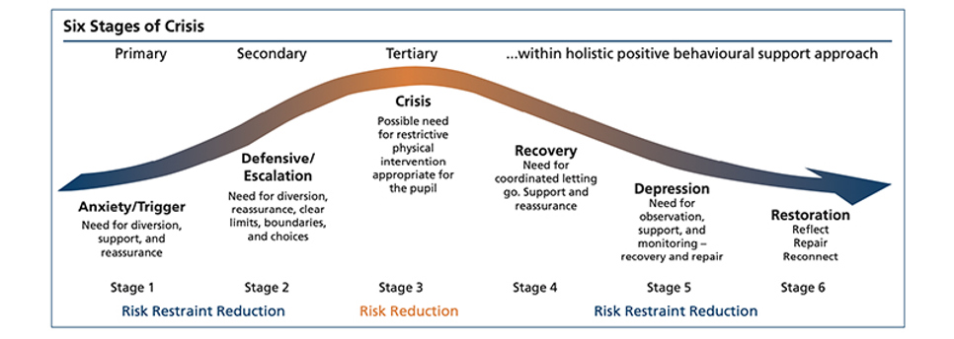
Figure 2: 6 stages of crisis

Dysregulation occurs when the brain responds to sensory input in a manner that triggers the state of crisis (fight, flight, freeze, flock, fawn). When a child is dysregulated, it is harder for them to listen, comprehend and cope.

4. Regulate, Relate, Reason
One of the key concepts is that we have to regulate before we can be open to relationships. It is through relationships that we will begin engaging in learning and reasoning. If a child is dysregulated because they don’t feel safe, and they do not feel connected to the person they are interacting with, their brain will keep their survival brain active and shut down other parts of the brain that it deems unnecessary until needs are met and they feel regulated again.

Sometimes we can’t do anything to change the adversity that children/families have experienced e.g. large- scale poverty. However, ensuring children feel safe and establishing genuine relationships helps to provide a buffer. It is vital to remember that
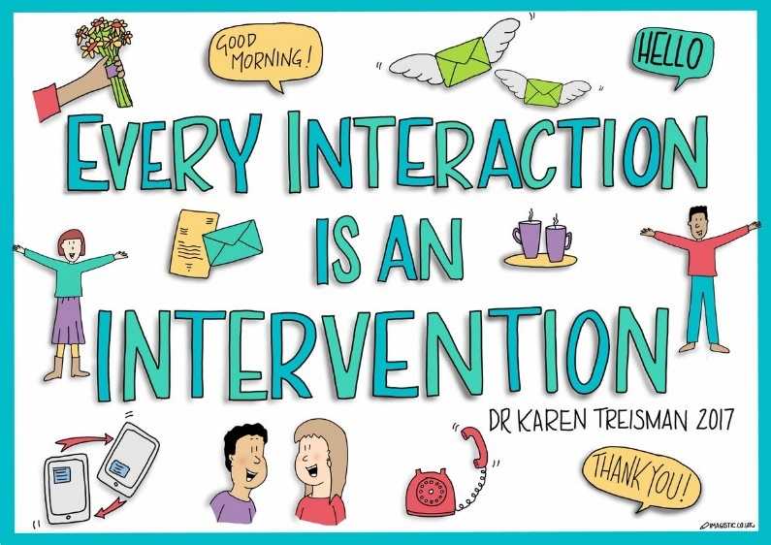

5. Positive support and de-escalation
Positive support refers to the graduated, proactive strategies used to help pupils regulate emotions, reduce anxiety and maintain safety.
Examples of positive support include:
- distraction and redirection (see below);
- offering considered choices or personal space
- calming language and tone;
- environmental adjustments (lighting, noise, seating);
- relational and trauma-informed approaches.

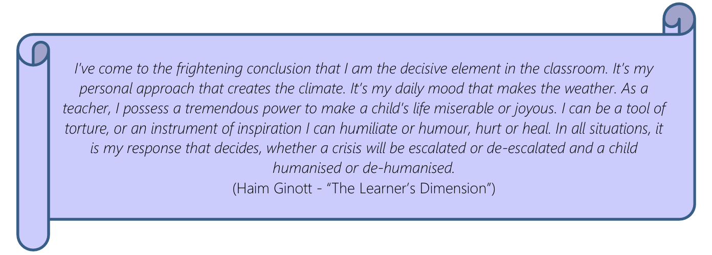

How all staff, in all schools, act: | - With PACE: Playfulness, Acceptance, Curiosity and Empathy  - Calmly following the policy;  - Consistently implementing the policy.
All members of our school  family will show respect for: | - Themselves  - Other people  - The school environment
All staff, every day: | - Will promote a positive culture  - PIP and RIP (Praise in Public and Remind in Private)  - Provide early intervention to support children’s behaviour (see step process)  - Teach how to behave
Senior leaders | - Will meet and greet around the school on a daily basis  - Engage in learning time and wellbeing walks to see positive behaviours, provide support and coach and model expectations.
Our key ways to recognise  behaviour that is ‘over and  above’: | Each school rewards in every school (listed below)
Support Beyond the  Classroom: (to be used for  change of face or to support  the restorative conversation.) | - Same year group team member, named TA, phase leader or another class teacher  - Inclusion Team  - Head of School

Positive support strategies are not restrictive interventions and do not require recording unless they form part of, or escalate into, a restrictive intervention.

6. Our agreed school rules
‘The standard you walk past is the standard you accept’ Paul Dix
Children and adults respond well to clear routines. Having clearly defined boundaries, expectations and routines helps to enable consistency. Children feel safe and secure when there is predictability.
ASI | ASJ | BI | DCT | STG
Our Rules:  - Be Calm  - Be Kind  - Be Respectful  This helps to keep us safe. | Our Rules – we are always safe:  - Ready  - Respectful  - Kind  How this looks:  1.Ready for school – all resources and equipment – arriving on time – attending. Ready to learn. Ready for the next stage in our learning journey.  2. Respectful to our school team: adults, peers. Respectful to our school environment. Respectful of our school ethos – tolerant of the views of others.  3.Kind to each other: living out our school values for reflection, showing forgiveness and compassion. | Our rules:  Be Safe  Be Ready  Be Kind  To be safe we must remember to:  Behave sensibly, keep hands and feet to ourselves and avoid hurting others. Walk around the school, not run. Ask permission to go to another room so the teacher always knows where you are.  To be ready we must:  Show we are ready to learn by following the school rules. Remember our best 5 - Ears listening, eyes watching, mouth quiet, hands still, legs crossed.  To be kind we must:  Treat others as we would like to be treated, follow our school values. Show respect for our property, school property and the property of others. | Our rules:  Be safe  Be ready  Be respectful  Being safe involves ensuring we behave sensibly, keep hands and feet to ourselves and avoid hurting others.  Being ready means ready for learning – for example following our school routines, listening to adults, putting hands up to ask questions.  Being respectful encompasses all other aspects of behaviour we expect in school – showing kindness, compassion, thankfulness and all the values that we embrace as a school community. | Our Rules:  Be Safe  Be Calm  Be Respectful

Our school rules are displayed in every classroom and central learning environments and used in daily school language and conversation with children at every opportunity to praise and to also re-direct where required e.g.: ‘Thank you for walking down the corridor…’That’s not what I meant when I said kind. Kind means…Being respectful looks like…’
- Consistency in practice
Consistency lies in the behaviour of adults and not simply in the application of procedure. A truly sustainable consistent approach does not come in a toolkit of strategies but in each whole school community having an agreed understanding of behaviour in the context of neuroscience.
The key is to develop a consistency that ripples through every interaction on behaviour. Where children feel heard and treated as valued individuals, they respect adults and accept their authority.
An essential element of our behaviour system is the relentless modelling and highlighting of our daily routines:
These need to be explicitly taught and rehearsed, formally and informally, so that everyone is clear of the expectations. Additions such as music cues, timers on screens, percussion instruments, clapping etc. may be helpful for younger children. Once children have mastered the routine, the countdown may be reduced e.g. to three. Learners are to be caught doing the right thing e.g. positive reinforcement to help embed the rules, routines and rituals.

- Movement in and around school
All movement in and around school should be purposeful and noise levels should be kept to a minimum. Staff should see that all children are suitably supervised when moving around the school. When moving through the school in large groups/classes, children are to walk in single file. Staff should regularly remind children that ‘calm walking means no talking.’

Calm walking means no talking
Moving calmly around school
What does this look like?
- Single file
- Voices off
- Ears switched on
- Eyes facing the front
- Hands down by your side
- One foot in front of the other
- Quiet footsteps on the ground
- Coming into school
How the day starts sets the tone for the rest of the day. We firmly believe that all children should receive a warm welcome as they enter school. Senior leaders, members of the Inclusion Team and class teachers will be on the gates each morning to greet children and their parents as they arrive into school.

- Breaktimes
Our rules should be embedded during playtime and lunchtimes.
It is important that staff involved in supervising playtimes and lunchtimes model positive play.
The environment plays a key role in supporting and extending children’s development and learning. Class teachers are responsible for ensuring that the playgrounds are well equipped with resources and activities that promote positive play. Staff should be positioned to safely oversee all areas of the playground/field so that there are no ‘blind spots’.
School staff will lead a daily SEMH Lunchtime Club for carefully prioritised children. The school’s leaders of lunch club are responsible for ensuring that resources, including board games, are of good quality and plentiful.
At playtimes, the escalated process within the classroom should be followed. If implementing Step 4 / 5 children will have reflection time on the calming bench on the playground/school field.
All lunchtime staff, including midday supervisors, are responsible for dealing with all behaviour issues during lunchtime. At lunchtimes, the graduated response to behaviour should be followed. In lieu of the calming corners in the classrooms, the benches on the playground / field are to be used. Or simply standing with a member of the lunchtime team to have quiet reflection.
- Lunchtime
Our school rules help to set out clear exceptions for behaviour during lunchtimes in the main school hall.
 | Marvellous Mealtime Manners
What does this look like?
On entry to the hall:  Walk into the hall quietly  Collecting your food:  Join the queue from the back of the line  Collect your tray and cutlery  Hold your tray with two hands  Wait for your food to be served on your tray  Remember to say please and thank you  Walk back to your allocated table place |  | During the meal  Stay seated in your chair  Tuck your chair towards the table  Use your quiet voice  Use your cutlery  Eat your dinner before your dessert  Put your hand up if you want help from an adult  Chew and swallow your food carefully | At the end of the meal  Stay seated in your chair  Wait to be called by an adult to empty your tray  Scrape your leftover food into the bin  Stack your tray  Tidy away your cutlery

- Coming in from playtime and lunchtime
As with the start of the day, how children re-enter the school has an impact on their next lesson and their readiness to learn. At the end of the class playtimes and lunchtimes, teaching staff alert staff using the the school bell and/or whistle.

- Ending a playtime
- Ring the bell
- All children are to stop what they are doing and stand still
- Put back the toy that you are holding / playing with (in 5, 4, 3, 2, 1….seconds)
- Ring the bell again
- All children are to stop what they are doing and stand still
- Instruct children to line up

7. Recognition, celebration and appreciation
Why crush behaviours with punishment when you can grow them with love? Visible consistency with visible kindness allows exceptional behaviour to flourish.
The best form of behaviour intervention acknowledges and enhances the positive. We firmly believe that every child has the right to be noticed, appreciated and celebrated. We use different online platforms (such as Class Dojo, ParentMail or Parent Pay) as a way of engaging parents as partner’s in their child’s education and maintaining good communication regarding their child’s personal development and achievements.

We use rewards to reinforce wanted daily habits, school routines, and learning behaviours, but we don't rely on rewards to manage behaviour or replace the development of intrinsic motivation (through our relational work, we want children to see the inherent value in their behaviour).

ASI | ASJ | BI | DCT | STG
Rewards:  We have a class reward system where we can earn stars for showing our three school rules of being calm, kind and respectful. We share how many stars each class has earned in celebration assembly and the class with the most stars receives a class reward.    We start everyday on the sunshine:  We can move up throughout the day and receive a sticker at the end of the day.    Rainbow:  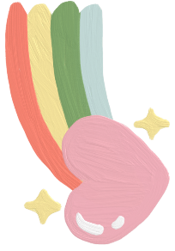  Jump over the rainbow:    Out of this world!:  Certificates in celebration assembly: star of the week, calm award, kindness certificate, respectful award. | Rewards:  Children collect Gold stickers for showing that they are: Ready, Respectful or Kind.  These can be given out by all adults that work in the school. These will be display on the class chart. Once the children have earned 50, they will receive a class reward.  (Each child will record their points next to their name every week). (Every week the points will be totaled and recorded on a central spreadsheet by the office).  (Positive behaviour points will be sent home on Termyl Report Cards).  2. Moving up to Silver or Gold and a Gold parentmail message home (stamps in books for daily Gold and Silver achievements)  3.Certificates in Celebration Assembly for: Star of the Week. Maths Whizz Class, Ready, Respectful or kind Award (led by the Ambassadors)  Etiquette Award voted over the week by the class. Etiquette award given out in Celebration Assembly.  4.Headteacher Awards given out for exceptional examples throughout the week such as in the dinner hall, on the playground or in Worship. | Rewards:  Recognise and reward appropriate behaviour.  (Look for examples in effort in work, discussions, kindness, co-operation and following instruction, etc.) and be specific with that praise.  Communicate and involve parents wherever possible in the positive reinforcement of their child’s achievements, to create and develop the team around the child.  Hold an expectation of success that is achievable by all.  Both classes have a reward system where they can earn Dojo points. When a pupil reaches 25 they get a dip in the box. The aim is that the children will get to 25 (or a multiple of) quickly to keep encouraging them to make the right choice. As a class when we reach 500 dojo points the children receive a reward of their choice. These get reset at the start of every half term.  Weekly certificates for Star of the week in Celebration Assembly.  Verbal rewards, stickers and dojos are given to all children and can be given by all staff. | Rewards:  We have a house point system where children are awarded points for demonstrating the qualities defined by our rules of being safe, ready and respectful. Children collect points individually but also for their house team – Robins, Magpies, Jays or Goldfinches. The team with the most points overall is recognized in our celebration assembly each week and children receive individual reward badges for reaching specified numbers of points (bronze 25, silver 50, gold 100, platinum 150). The house with the most points overall receives a reward – such as extra break time – at the end of each half term. House points are then reset for each house but not for individual children. Individual house points reset at the end of the school year.  In addition, we use a traffic light system to recognize behaviour in class and around school. All children start each day on green and can then move up to silver or gold or down to amber or red. If children move to gold or red then a message is sent to parents. | Rewards:  1.We have a house point system where children are rewarded individually for showing that they are being safe, calm and respectful.  These can be given out by all adults that work in our school. At the end of the week the house captains count all the points from the classes and the result is shared in the Friday celebration worship. The house with the most points for that week will earn the extra opportunity to use the cosy corner and scooters during break and lunch time.  The house with the most points at the end of the half term will be shared in the Friday Celebration worship and the house captains will spin the reward wheel. The children of the winning house will then have this reward together. This reward varies from extra break to film and popcorn.  2. We have a class reward system where the children can earn stars as a team when demonstrating our three school rules:  Be safe, be calm, be respectful. When the children have earn 10 stars in their jar this will be celebrated in our Friday celebration worship. The children alongside their class teacher we have discussed their reward such as golden time, film afternoon, hunt around school, extra break and more.  3.Weekly certificates in Celebration Assembly for: Star of the Week, Maths Whizz Class, kindness spotlight. The children will also be rewarded for demonstrating the schools’ values of kindness, compassion and perseverance. The children will put their names on the flags in the school hall to show the school community that they are running the race that is before them.  4.Verbal rewards and stickers will be given to all children; including nursery.

When recognising habits, routines and learning behaviours, the member of staff should reinforce the wanted behaviour e.g. ‘You can have a reward for holding the door open and showing good manners, thank you.’ Once awarded, a reward can never be deducted.
In addition to this, each class will have a ‘Recognition Board’. As a class, children and adults will decide on a specific area linked to our school rules that they would like to improve e.g. one voice if children keep talking over each other. The aim is to get everyone's name on the board by the end of the session/day/week (depending on the age of the class/context).
When staff see children demonstrating the behaviour well, they are to acknowledge this on the board. It is important that:
- children are recognised for effort, not achievement
- this is viewed as a collaborative strategy (it is not intended to shower praise on the individual)
- teaching staff pursue the behaviour they want by chasing it hard and reinforcing it enthusiastically
there is a shared sense of team work and collective accomplishments.

8. Responding to behaviour incidents in a relational way
We endeavor to deal with the majority of behaviour incidents with prompt and pro-active support in relational way. The Anger Iceberg Model (see below) recognises that anger is often just the tip of the iceberg, and there are deeper emotions and needs that need to be addressed.
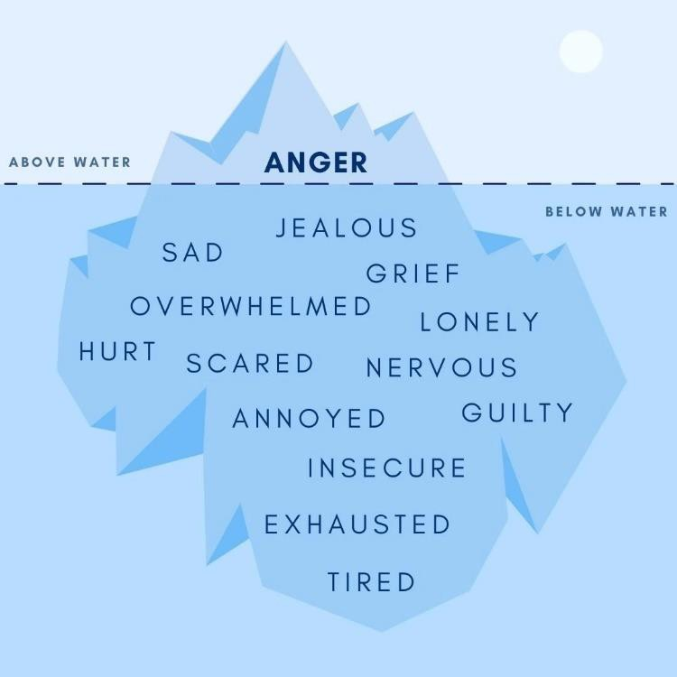

Instead of being considered ‘problematic’, angry and aggressive behaviours must be viewed as self-protective coping mechanisms. Instead of asking, ‘’What is wrong with you?’ and ‘Why are you doing that?’ we must extend our curiosity outside of the child and ask: ‘What happened to you?’
We do not:
- refer to behaviour and/or emotions as positive (good) or negative (bad);
- use shame or punitive consequences;
- shout (there is a clear difference between a raised voice and shouting as this is a loss of control).

NB: Although shouting must not be used as a classroom management technique, there may be occasions when it is necessary to use a raised voice i.e. to be heard on the playground etc).

In line with the the Trust’s policy on restricive intervention (Section 3.5), staff will not resort to use restrictive interventions and force without first questioning whether:

- There are actions that can be taken to remove triggers from pupils, e.g. dimming the lights and encouraging quiet where a pupil goes into crisis/becomes dysregulated in response to sensory overstimulation.
- The pupil can be removed from the situation without restrictive intervention, e.g. if they will follow a member of teaching staff out of the classroom.
- Verbal de-escalation can be attempted, using positive language.
- The pupil has a condition or support needs that mean restrictive intervention would be inherently more dangerous, e.g. asthma which may be made worse by restrictive holds or sensory issues where physical touch would contribute to sensory overload and may provoke aggressive behaviour.
- They have the ability, training and adequate support to physically intervene safely without causing unnecessary harm to the pupil or themselves.

Instead, we:
- refer to behaviour as wanted or unwanted in the correct context;
- express our displeasure with the action and never the child i.e ‘That was an unkind thing to do because…’ and not ‘You are an unkind boy’;
- praise in public;
- reprimand in private;
- use consequences that focus on reflection, learning and growth.

9. Our graduated approach to behaviour
The following chart is a guide to help all staff respond to behaviour incidents consistently. When looking at the chart, the age and stage of the child and the context of the behaviour incident are always important to consider.

 | A  (lacking thought) | B  (lacking care) | C  (lacking empathy) | D  (lacking safety) | E  (intentional harm)
 | low level unwanted behaviour |  | serious unwanted behaviour
 | Mistake Ill-judged Careless Impulsive | Disruptive  Rude Unkind Horseplay  If no action after warning. | Antagonistic Ignorant of others  Danger play Persistently disruptive and disrupting learning (after 1 and 2) | Negligent Misadventure  (element of planning)  Dangerous Aggressive | Violent Abusive Planned or malicious
Input from | Classroom teacher | Classroom teacher | Child is accompanied to phase leader or partner class teacher (TA called by class teacher using walkie talkie). | SLT/Head of School | Headteacher
Log on CPOMs? | - No | YES  (Record on CPOMS and close the incident) | - Yes  (Record on CPOMS as active)  Phase leader or DDSL triages the concern and categorises accurately before updating and closing concern once confirmation all completed. | - Yes  MyConcerns record opened by CT and triaged by DSLs  (Record on CPOMS as active) | - Yes  (Record on CPOMS as active)
Parental involvement? | No | Informally with the teacher | Restorative framework sheet sent to parent | Yes | Yes
Action | Warning  ‘Nip in the bud’  ‘Benefit of the doubt’  2 minute warning for SEND children? | 5 minutes of free/choosing (unstructured) time (undertaking restorative practice).  Potentially move to the restorative framework sheet (Appendix 1) verbally. | Supervised time out within a neutral environment:  Restorative framework: undoing poor behaviour (Appendix 1).  Teacher shares action and the correction with parents on the day. | Child is enabled to calm down and regulate (either in their classroom once other children have been withdrawn or in a safe space).  Internal exclusion: working in senior leader’s office.  Meeting with parents with phase leaders and SLT | In-Year Fair Access protocol  / Consideration for exclusion*
Consequence:Steps on the  Graduated Approach | 1 and 2 | 3 and 4 | 4 and 5 | 6 and 7 | 7
Repeated presentations of A and or B behaviour may lead to escalation of support and intervention alongside our Graduated Approach to Behaviour

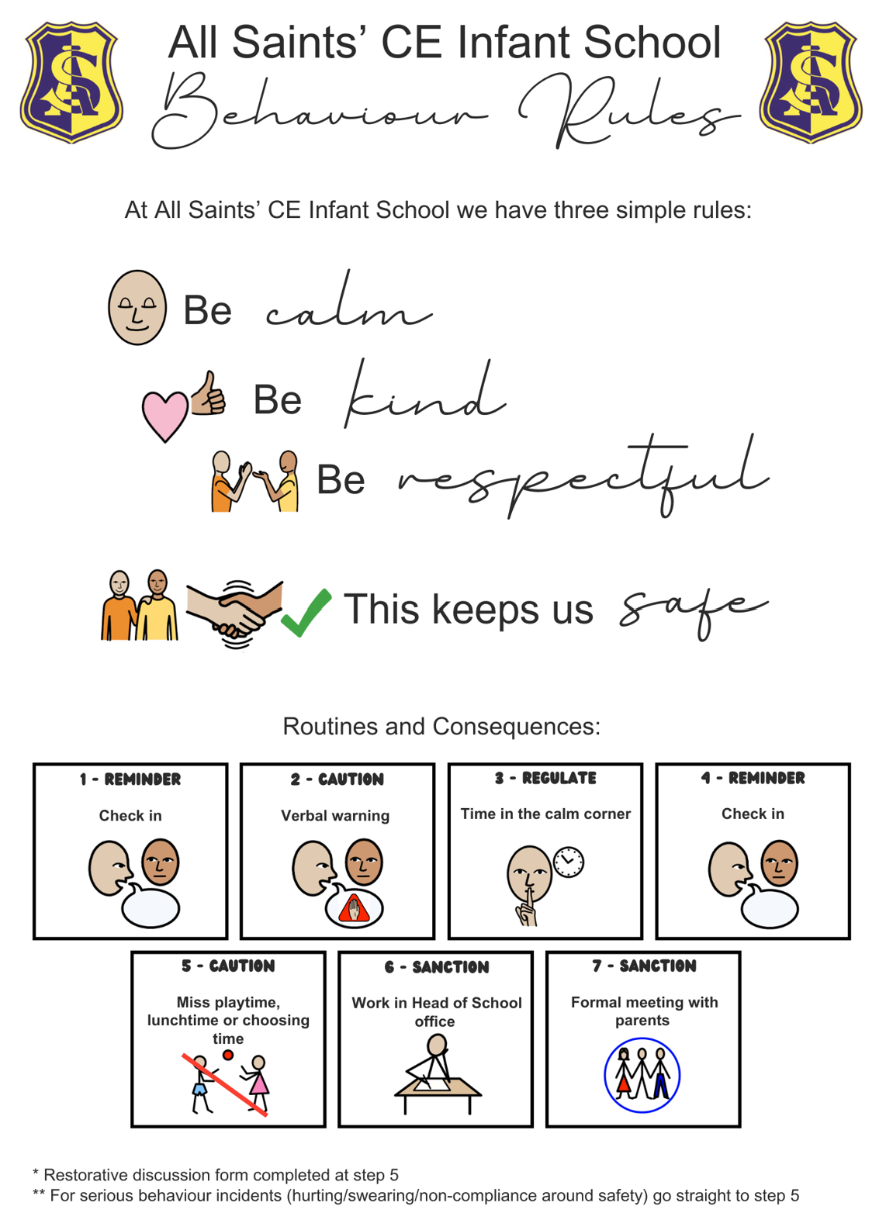

All Saints’ CE Junior: Family, faith, flourish

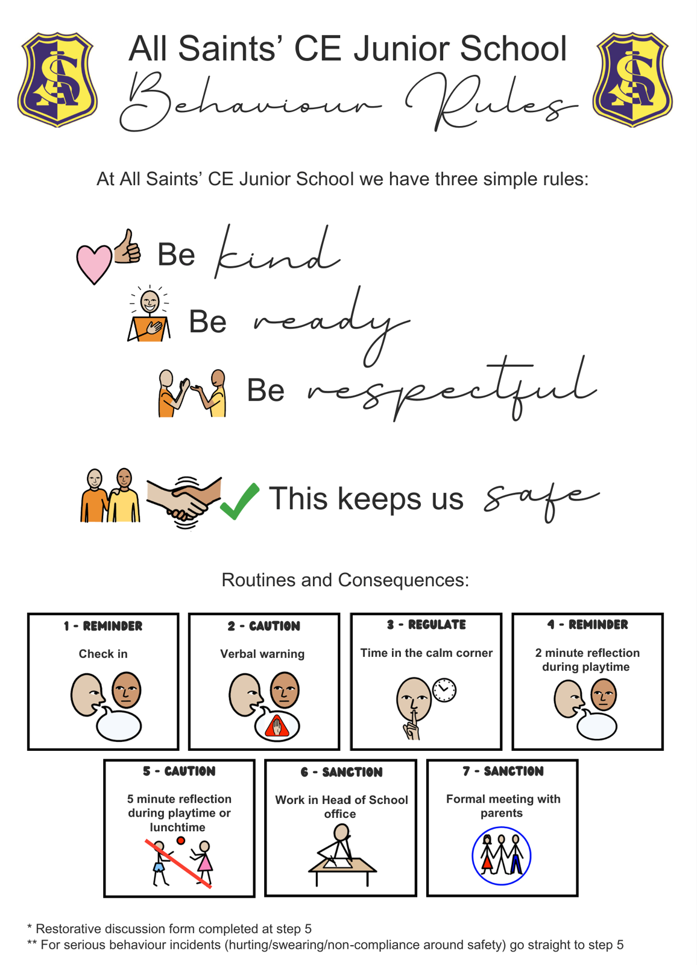

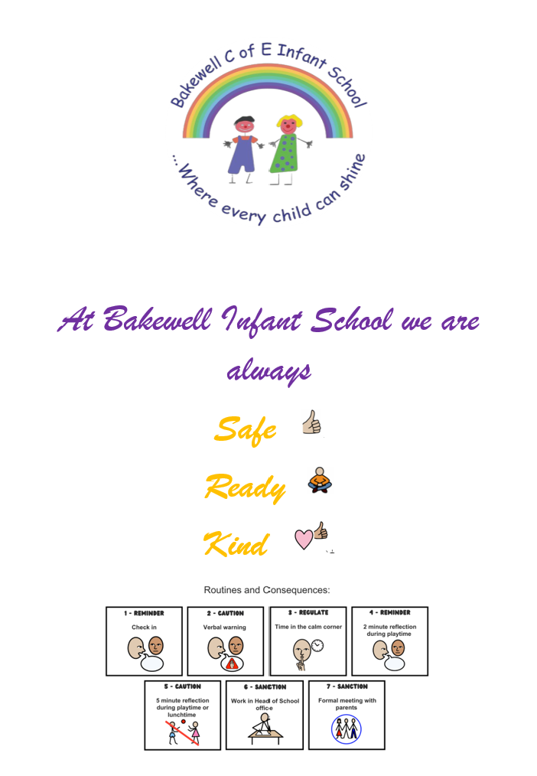
- Bakewell CE Infant: Be the light for others, so they will see God in the good things you do

- Darley Churchtown CE Primary: Aim high and believe, grow and succeed
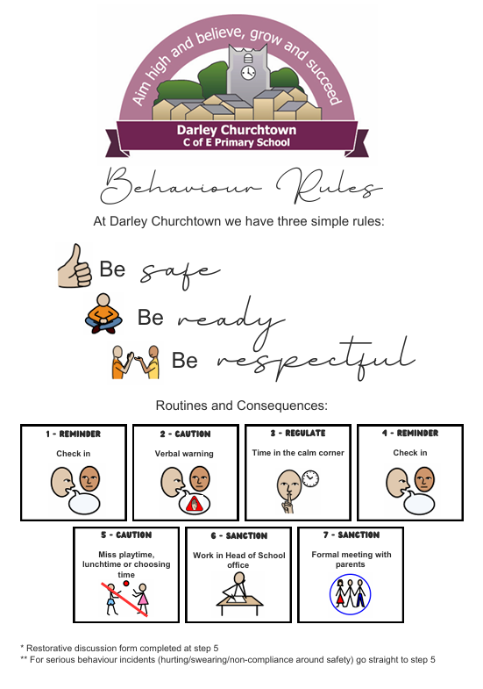

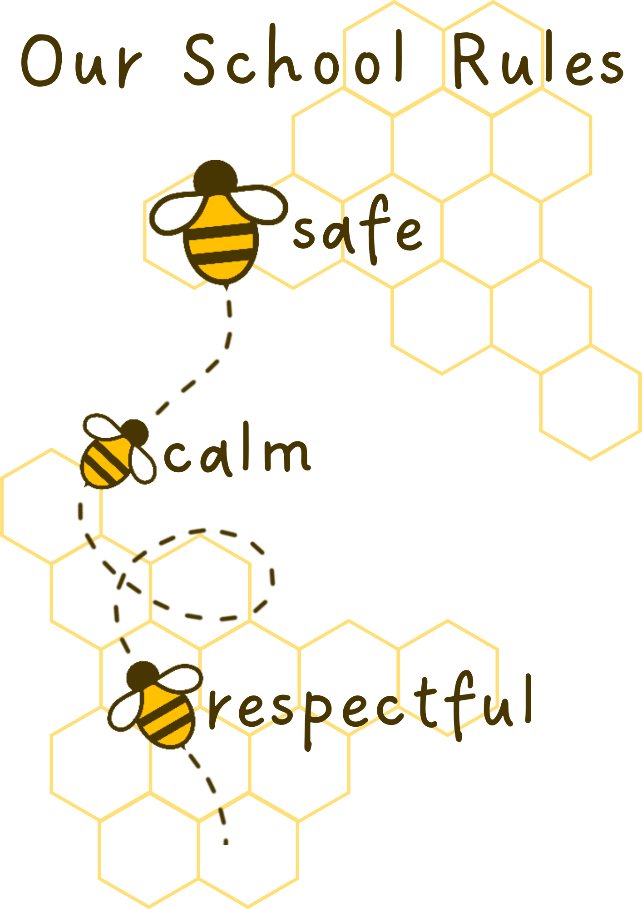
- St. Giles CE Primary: Let us run the race before us and never give

Appendix 2: Restorative Discussion: Listen, Link, Learn
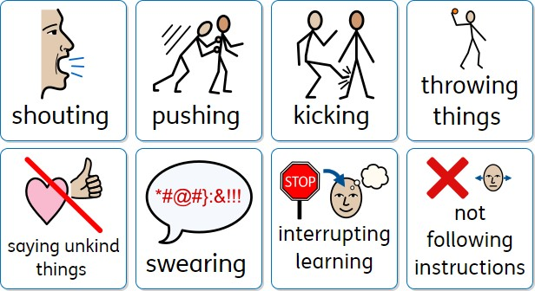
What happened? Be open and clear about your interpretation of the incident if they cannot remember e.g. I saw

What was I thinking and feeling? What could I do next time?
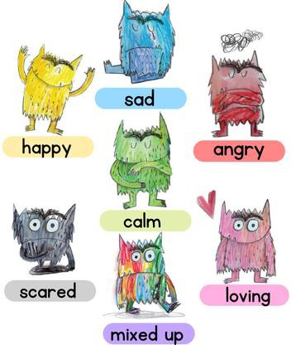
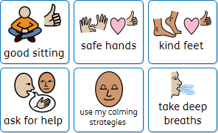

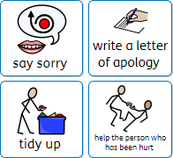
How can I make it better? How can I show that I am sorry?

Appendix 3: What happens when a child is unable to regulate their emotions or behaviour.

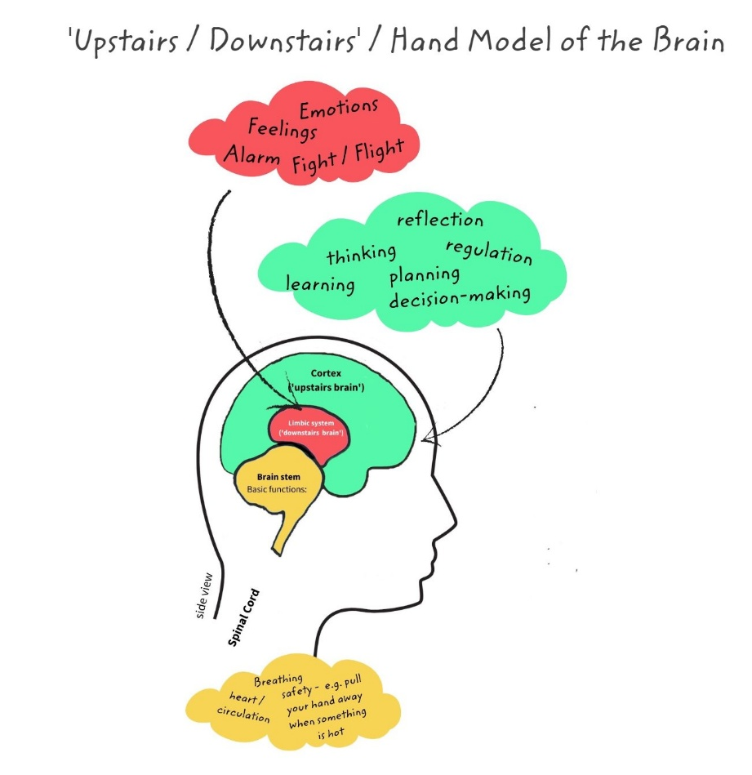
Sometimes a child has a limited capability in their ​upstairs brain as they develop and at times ​access to their upstairs brain is ​completely shut off.

This leads to meltdown and being fully ​immersed in the emotion and unable ​to think logically.

In a conflict situation we decide which part of the brain we are appealing to.
We know that if we present an ultimatum we enrage the downstairs brain​
Ask how it made the child feel we engage the upstairs brain​

Sometimes the temptation is to make all the decisions for our children so that they consistently do the right thing. ​ But as often as possible, we give them practice at making decisions for themselves. Decision making requires executive functioning, which occurs when the upstairs brain weighs different options. ​
​
We teach our children self-understanding:
​
Why do you think you made that choice?​
What made you feel that way?​
What if you feel like that again? How do you think you might handle it?​
What is something you can do to make you feel better
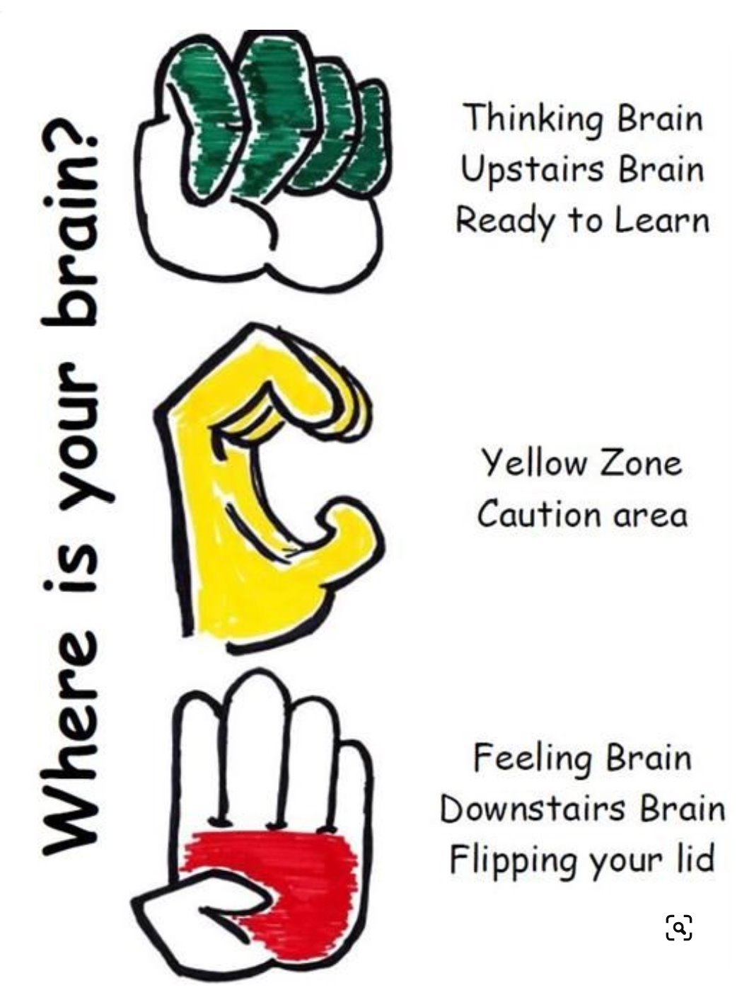
Research shows that bodily movement directly affects brain chemistry. ​

A lot of emotion that we feel actually begins in the body. Churning stomach, tense shoulders; these send physical messages to the brain before we even realise that we’re nervous. ​

Vigorously moving our body releases angry energy and tension allowing us to relax. ​
​
I know you’re upset that you didn’t get picked to be at the front of the line..

It doesn’t seem fair does it?​

Why don’t you come and get a scooter out with me and we’ll talk about it

​

Flourishing for All: Anti-bullying Guidance for Church of England Schools. (2024). Available at: https://www.churchofengland.org/sites/default/files/2024-09/nse-flourishing-for-all-part-a-and-b-for-publication-september-2024-1.pdf [Accessed 12 Nov. 2024].
Treismann, K. (2017). Working with relational and developmental trauma in children and adolescents. London ; New York Routledge. ‌
Dix, P. (2017). When the Adults Change, Everything Changes : Seismic Shifts in School Behaviour. La Vergne: Crown House Publishing.

