Bakewell CE Infant school Pupil premium strategy statement

This document reflects year 1 of our renewed three-year strategy, starting in September 2025.

Our statement details our school’s use of pupil premium funding to help improve the attainment of our disadvantaged pupils.

It outlines our pupil premium strategy, how we intend to spend the funding in this academic year and the effect that last year’s spending of pupil premium had within our school.

School overview

Detail | Data
School name | Bakewell C of E Infant School  Bakewell
Number of pupils in school | 36 (November 2025)
Proportion (%) of pupil premium eligible pupils | 36.1% (13 children)
Academic year/years that our current pupil premium strategy plan covers (3 year plans are recommended) | 2025 – 2026 – July 2028  Year 1
Date this statement was published | December 2025
Date on which it will be reviewed | Mid-year 2026. End of year July 2026.
Statement authorised by | Ben O’Connell  Headteacher
Pupil premium lead: Head of School | Mrs. EJ Harry
Governor / Trustee lead | Mrs. C Dathan

Funding overview

Detail | Amount
Pupil premium funding allocation this academic year | £19,695
Recovery premium funding allocation this academic year | £0
Pupil premium (and recovery premium*) funding carried forward from previous years (enter £0 if not applicable) | £0
Total budget for this academic year  If your school is an academy in a trust that pools this funding, state the amount available to your school this academic year | £19,695

Part A: Pupil premium strategy plan

Statement of intent
At Bakewell C of E Infant School, our mission is to provide a nurturing, inclusive environment where every child is empowered to flourish and ‘shine’ so that the achieve, belong and thrive. Inspired by our Christian ethos and the teaching of Matthew 5, we strive to be a light for others through the good we do.

Our school’s pupil premium strategy is rooted in the belief that all children, regardless of background or circumstance, deserve equitable access to a high-quality and excellent education. We are committed to ensuring that our disadvantaged children make strong progress from their starting points and achieve highly by removing all barriers to learning and promoting excellence for all.

Central to our approach is the collective responsibility of all staff (teaching, pastoral and support) in understanding and addressing the challenges of educational disadvantage. We prioritise high-quality teaching as the most effective lever for closing attainment gaps, complemented by targeted interventions and personalised support where needed.

We rigorously monitor the impact of our strategy through ongoing formative assessment, termly data reviews and daily attendance tracking with a particular focus on pupils with higher levels of need. Any concerns are addressed swiftly through collaboration with families, staff, and external agencies.

Beyond academic achievement, we recognise the importance of nurturing the whole child. Our strategy includes provision for social and emotional development, ensuring disadvantaged pupils can engage successfully in all aspects of school life: so that they belong and thrive as they grow into confident, resilient learners.

Through this strategy, we aim to create a school culture where every child feels valued, supported and achieves success.

Challenges at Bakewell CE Infant school
This details the key challenges to achievement that we have identified among our disadvantaged children.

Challenge number | Detail of challenge
1 | A significant proportion of disadvantaged pupils enter school below age-related expectations in writing. Baseline assessments consistently show underdeveloped fine and gross motor skills, limiting their ability to engage in early mark-making and transcription activities.  This lack of physical readiness, compounded by limited early exposure to writing opportunities, impedes progress in foundational literacy.
2 | Many disadvantaged children have underdeveloped language skills, stemming from limited exposure to structured talk, rich vocabulary and high-quality interactions within pre-school environments.  This deficit affects too many children’s ability to communicate effectively, express understanding and, noticeably for a minority, self-regulate. This is evident within the Early Years Foundation Stage where Communication & Language and Self-Regulation are persistent areas of concern.
3 | A significant number of disadvantaged pupils face barriers in early reading development, particularly in phonics. These include:  - Difficulty in recognising sounds, decoding, segmenting, and blending words.  - Limited reinforcement of phonics learning at home, with low engagement in the school's phonics reading scheme.  - Restricted access to high-quality texts and limited opportunities to be read to regularly.  These challenges contribute to slower progress in early literacy and widen the attainment gap.
4 | Internal data highlights a rise in social and emotional difficulties among disadvantaged pupils, including increased anxiety, low self-esteem, and poor choices in behaviour.  These issues negatively impact children’s engagement, learning behaviours and academic attainment, requiring targeted support and whole-school approaches to further support wellbeing and emotional literacy.
5 | Many children enter school with limited prior experience of foundational mathematical concepts, particularly in number, geometry and spatial reasoning.  This lack of early exposure impeded and acquisition and development of operations and problem-solving strategies. Without mastery of these building blocks (often acquired through a non-linear, spiral curriculum) children struggle to progress to more complex mathematical thinking.

Intended Outcomes
This explains the outcomes we are aiming for by the end of our current strategy plan (July 2028), and how we will measure whether they have been achieved.

Intended outcome | Success criteria
Improved attainment in writing across both EYFS and KS1, with children accurately transcribing. | - 90%+ of children demonstrate age-appropriate fine motor control by end of Reception (e.g. accurate ‘tripod’ pencil grip and scissor use).  - Writing moderation shows improved transcription skills and sentence formation in KS1.
Observations and assessments show improved self-regulation and expressive language. | - All children participate in daily structured oracy activities (e.g., talk partners, storytelling).  - Vocabulary assessments show accelerated progress for disadvantaged pupils.  - Observations and assessments show improved self-regulation and expressive language in EYFS and KS1.
High attainment in phonics and early reading (both fluency and comprehension) | - 85%+ of disadvantaged pupils pass the Year 1 Phonics Screening Check.  - Increased parental engagement in reading (e.g., home reading logs, workshops).  - All children access high-quality texts and are read to daily.
Children demonstrate improved emotional literacy, self-esteem and engagement in planned learning. | - Reduction in behaviour incidents and suspensions among disadvantaged pupils.  - Pupil voice surveys show improved wellbeing and sense of belonging.  - Staff report increased engagement and resilience in learning behaviours.
High attainment in numeracy (number, geometry and in the application of operations). | - Observations show confident use of manipulatives and mathematical language in EYFS.  - 80+ of disadvantaged pupils meet ARE by the end of Early Years.  - 80%+ of disadvantaged pupils meet age-related expectations in maths by the end of KS1.

Activity in this academic year

This details how we intend to spend our pupil premium this academic year to address the challenges listed above.

Teaching (for example, CPD, recruitment and retention)
Budgeted cost: £2,050

Activity | Evidence that supports this approach | Challenge number(s) addressed
Training on development of pencil grip/fine motor (from palmar supinate -> tripod) | There is an established link between effective fine motor and unlaboured mark marking: ‘There is also a link between physical development and literacy in the area of handwriting’ EEF/Early Years/Physical Development This is further evidenced within the Dfe’s Writing Framework with pupils with handwriting difficulties ‘will find composition difficult, as their working memory is heavily loaded with the demands of transcription’. | 1
Transcription training for all staff and continued focus on planning and teaching early writing in school according the new writing curriculum. | ‘Develop pupils’ transcription and sentence construction skills through extensive practice’ EEF/Improving Literacy…  Section 3 of the Dfe’s Writing Framework ‘Fluent handwriting is a significant predictor of positive writing outcomes,’ | 1
Planned release for moderation to ensure highlight quality provision and outcomes are secured | Internal moderation is a non-statutory, but vital, process conducted in schools and, where possible, with other schools. Moderation should be collaborative, undertaken throughout the year and normally with teachers across key stages. This supports the quality assurance of teacher assessment judgements and provides an opportunity for professional development. Dfe’s Writing Framework p97 | 1
Training for all staff (teachers and TAs) on the vocabulary curriculum to ensure carefully sequenced teaching and assessment of tier 2 vocabulary within the EYFS into KS1. | EEF Developing vocabulary in the EY: Improving young children’s vocabulary is often a high priority, particularly when teaching students from disadvantaged backgrounds who are more likely to have a less extensive vocabulary. | 1 & 2
Training on Little Wandle programme (including SEND) for teachers and TAs | EEF The importance of reading… | 2 & 3
SEMH approaches to become embedded into routine educational practices such as through taught PSHE and Circle Time in the Classroom and use of resources such: The Worry Book to help prepare children for everyday difficulties and enable them to overcome these themselves. | EEF social and emotional learning: Alongside academic outcomes, SEL interventions have an identifiable and valuable impact on attitudes to learning and social relationships in school. | 1, 2, 3, 4 & 5
Review and secure appropriate maths scheme to meet expectations within EY and KS1, ensuring indoor and outdoor provision is enabled following staff training | EEF Early maths | 2 & 5

Targeted academic support (for example, tutoring, one-to-one support structured interventions)

Budgeted cost: £12,500 costs (plus £0) Total: £12,500

Activity | Evidence that supports this approach | Challenge number(s) addressed
Establish school led Nurture and Positive Play provision, overseen by locally based SENCO | EEF social and emotional learning: Alongside academic outcomes, SEL interventions have an identifiable and valuable impact on attitudes to learning and social relationships in school. | 2 & 3
MathsWhizz: implement consistent approach to MathsWhizz daily, focusing on the three foundational elements from EEF. | EEF trial has entered the second phase: EEF Whizz Efficacy Trial - Maths-Whizz | 5

Wider strategies (for example, related to attendance, behaviour, wellbeing)
Budgeted cost: 2,840

Activity | Evidence that supports this approach | Challenge number(s) addressed
The partnership’s Inclusion Team provide additional and targeted SEMH to support the wellbeing of children. | The review undertaken by the EEF on social and emotional learning (SEL) reported that, ‘Alongside academic outcomes, SEL interventions have an identifiable and valuable impact on attitudes to learning and social relationships in school’. We continue to heed the cautionary finding shared by the EEF that ‘this finding, however, has very low security, so schools should be especially careful to monitor the efficacy of SEL approaches in their settings. | 4

Total budgeted cost: £17,390

Part B: Review of outcomes in the previous academic years

Outcomes for disadvantaged pupils
We have analysed the performance of our school’s disadvantaged pupils across the period of the previous PP strategy, drawing on national assessment data and our own internal assessments. In line with the achievement statement within the latest Ofsted toolkit (5th November 2025), we have used the word: typically. This reflects the small cohort sizes.
1. Writing: There is a need to continue focusing on emergent writing to ensure all children are well placed for the rigours of KS1.
2. Phonics: Typically, typically our disadvantaged pupils achieve the PSC in Year 1 with our latest outcomes evidence national + for all, with 100% for our disadvantaged. We need to further sustain these standards.
3. Early number: typically our disadvantaged pupils secure Number and patterns at the end of EY, enabling them to secure the demands of KS1.Consequently, the majority of pupils achieve ARE by the end of KS1.
4. Wider opportunities: all children engage in a planned programme of opportunities.
5. Low attendance and punctuality: whilst attendance continues to be a strength (see the latest figures), a comparison with similar schools highlights that, on occasion, attendance remains a barrier for individuals (noticeably with anxiety and ESBA)
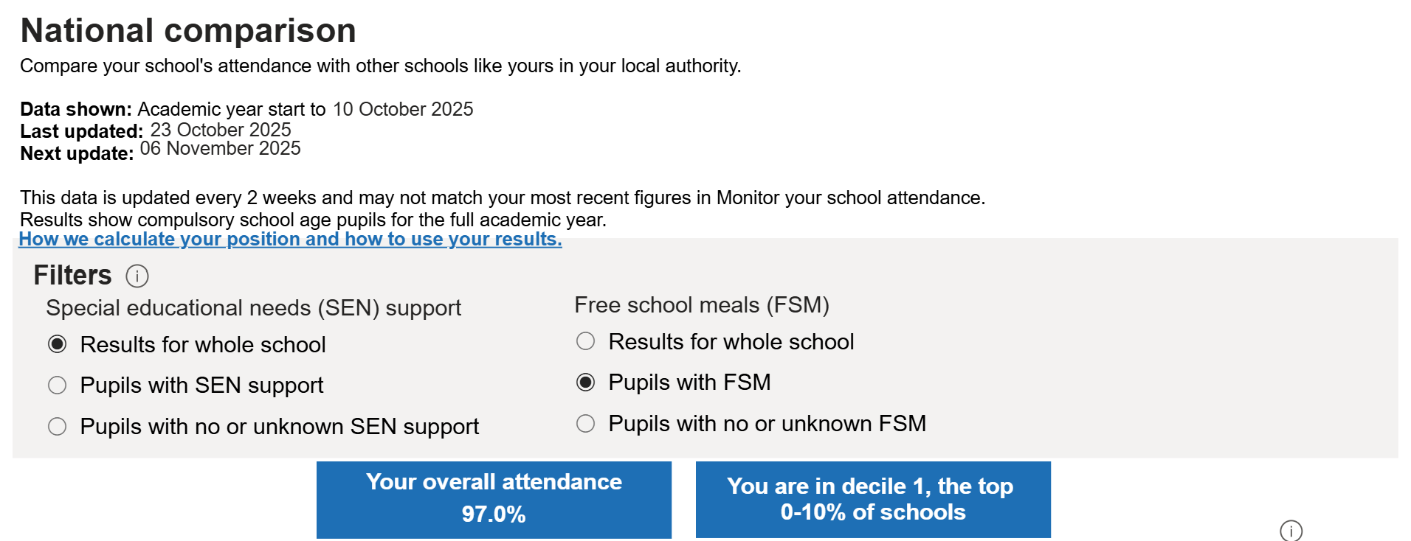
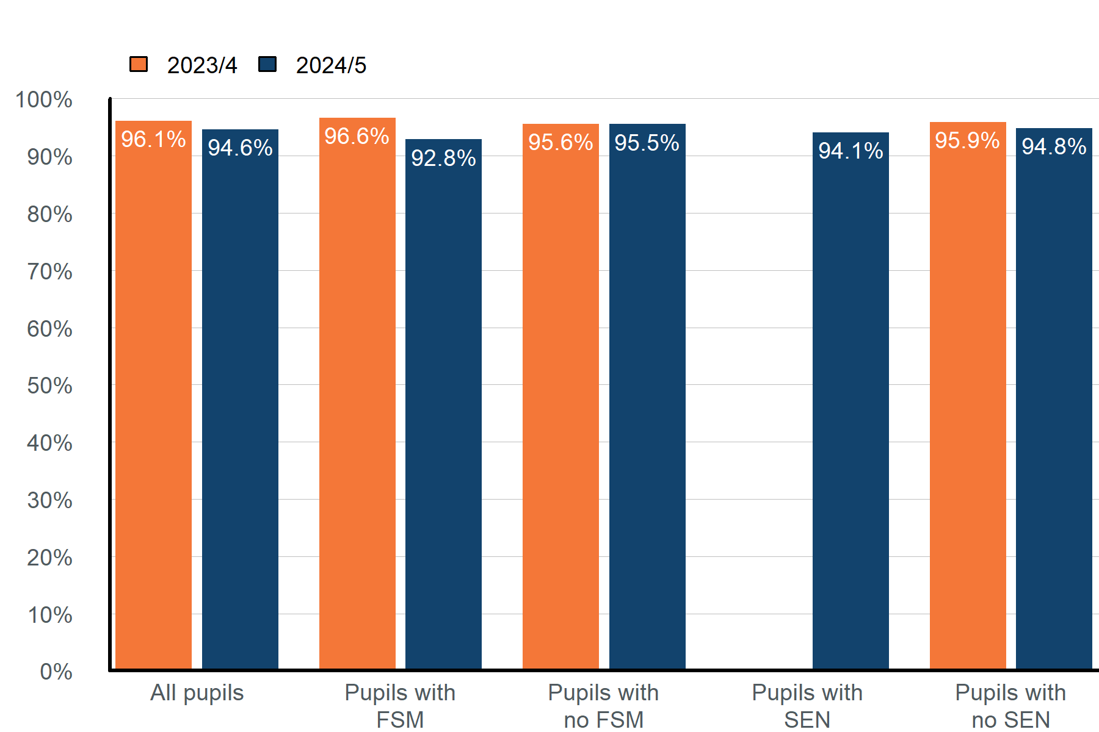

Part B: Review of outcomes for the 2024/25 academic year

This details the impact that our pupil premium activity had on pupils in 2024 to 2025

Overall Outcomes
☐ Good progress ☐ Average progress ☐ Minimal progress

Due to small cohort sizes, it is important to be cautious when making direct comparison with attainment data from previous years. However, the achievement in phonics and maths typically show sustained increases. This needs consolidating whilst we further strengthen achievement in early writing, number and oracy.

Teaching

☐ Good progress ☐ Average progress ☐ Minimal progress

Whilst there has been progress in better understanding the barriers which can stymie some children, more work is needed to ensure that all staff are equipped with the knowledge and skills to provide the relentless support which is needed.

Targeted academic support

☐ Good progress ☐ Average progress ☐ Minimal progress

There is evidence that pupils in Key Stage 1 are making good progress from stronger end points at Early Years. The use of Maths Whizz is further supporting children’s foundational knowledge and fluency, supporting strengthening attainment. This needs consolidating.

Wider strategies

☐ Good progress ☐ Average progress ☐ Minimal progress

There has been excellent progress in supporting and sustaining children’s attendance. Where individuals have found attendance challenging, the Inclusion Team have provided support which has enabled attendance to rapidly improve. The increased resourcing, including our own Family Support Worker, is further reducing perceived barriers and has increased the capacity of support which the school can provide to vulnerable children and families.

All children engage with all opportunities, regardless of barriers. As a result, all children are enabled to shine in sport, music and wider provision.

Externally provided programmes
Please include the names of any non-DfE programmes that you purchased in the previous academic year. This will help the Department for Education identify which ones are popular in England

Programme | Provider
Little Wandle Phonics | Litte Wandle
Maths No Problem | Pearson
Maths Whizz | Pearson
Nessy | Educational

Service pupil premium funding (optional)
For schools that receive this funding, you may wish to provide the following information:

Measure | Details
How did you spend your service pupil premium allocation last academic year? | Not Applicable
What was the impact of that spending on service pupil premium eligible pupils? | Not Applicable

We used the EEF’s implementation guidance to help us develop our strategy, alongside the Education-evidence/teaching-learning-toolkit This helped us prioritise our approach and spending based on the research exploring which strategies have the greatest impact. Our own data helped us identify our key focus for this year and re-shape our 3year plan accordingly. Aided by Ofsted research, papers released by the DfE and our own educational reading we continue to look for ways of using the funding to have the greatest impact and improve the lives for our most disadvantaged children.

