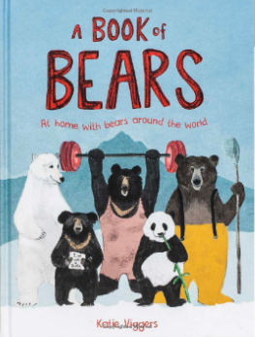
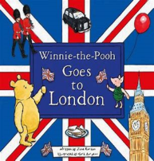
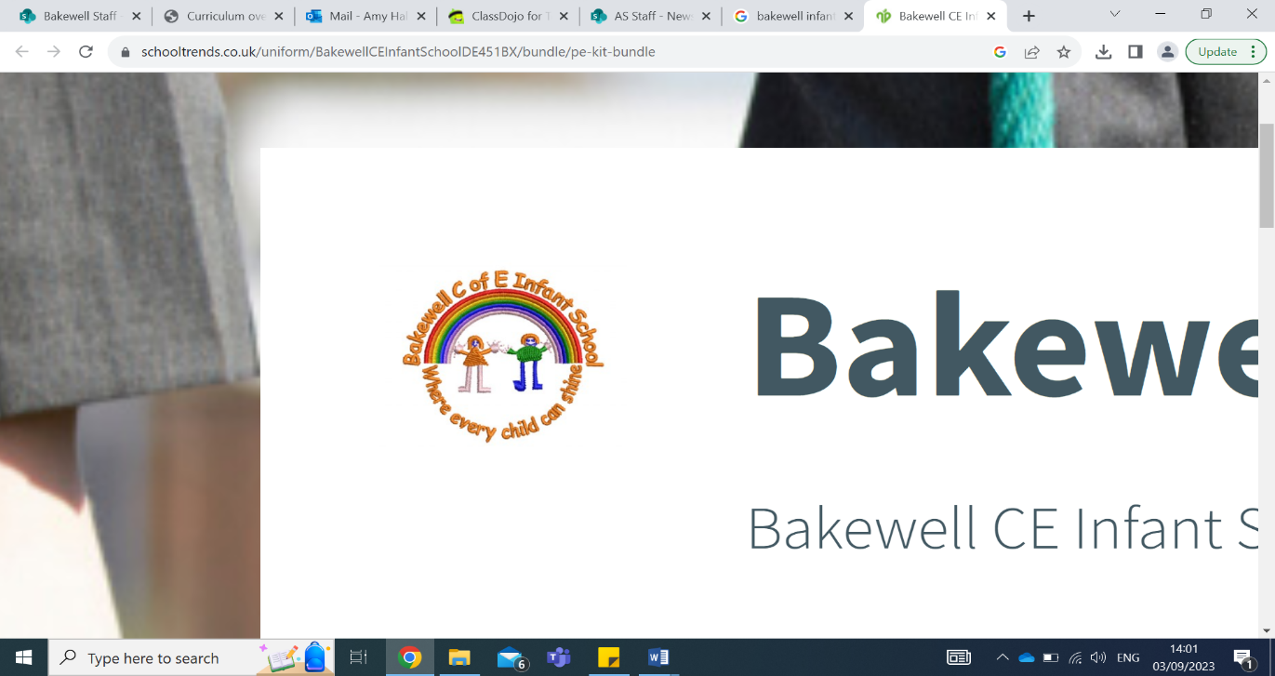
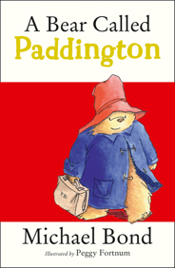
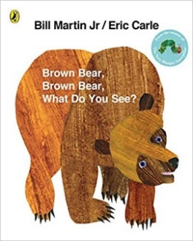
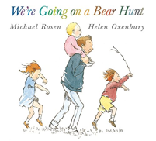
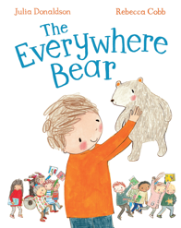
Koalas recommended read:

Learn all about the 8 different bears of the world, their likes, their homes and more. Who is the best climber and who is the fastest at catching fish?
Reminders:
Our PE day is now Thursday. Children are invited to come to school wearing their PE kits on these days.
Homework is sent out on Wednesday to be returned the following Tuesday. Please also read with your child at least 3 times a week and sign and date their reading records. Reading books are changed when your child has read in school 3 times, usually on Thursday or Friday.

Diary dates:
23rd September: Book Fair
9th October: School Photographs
15th October: KS1 Sports Event
21st and 23rd October: Parents Evenings
24th October TBC – Harvest Celebration
Key learning this half term:
This term our topic is ‘Bears, Bears, Everywhere’. We are looking forward to learning about bears old and new!
In Year 1 phonics we will continue to use Little Wandle to ensure our children can read fluently and with prosody and understanding. This term we will revisit Phase 3 sounds before moving on to Phase 4. In Year 2 spelling we will be reviewing phase 5 phonics before we bridge to spelling using the Little Wandle spelling scheme.
In Writing we will be focusing on forming all letters correctly, using finger spaces and punctuating sentences. We will enjoy exploring our class texts and responding by writing descriptions, postcards and retelling the story.
In Maths Year 1 will be looking at place value to 10, addition and subtraction, and position. Year 2 will be looking at place value to 100, addition and subtraction, and multiplication and division of 2, 5 and 10.
In Geography we will be learning how to record weather patterns using a weather chart, and compare London to Peru. In Science we will be learning about the changes that happen during each season.
In Art we will be looking at mark making using line and drawing from observation. In Music we will be learning about finding the beat or the pulse in music.
In Computing we will be learning about the technology around us.
In PE we will be learning to attack, defend and shoot!
In PSHE we will be learning about being healthy. In RE we will be learning about Christians - who they are and what they believe.
Koalas Autumn Term 1 2025 Newsletter
Our class texts…

