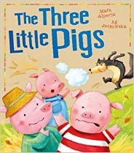
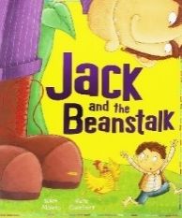
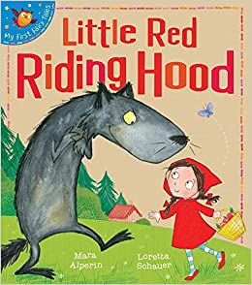
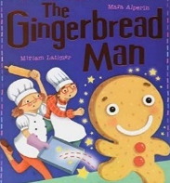
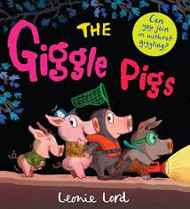
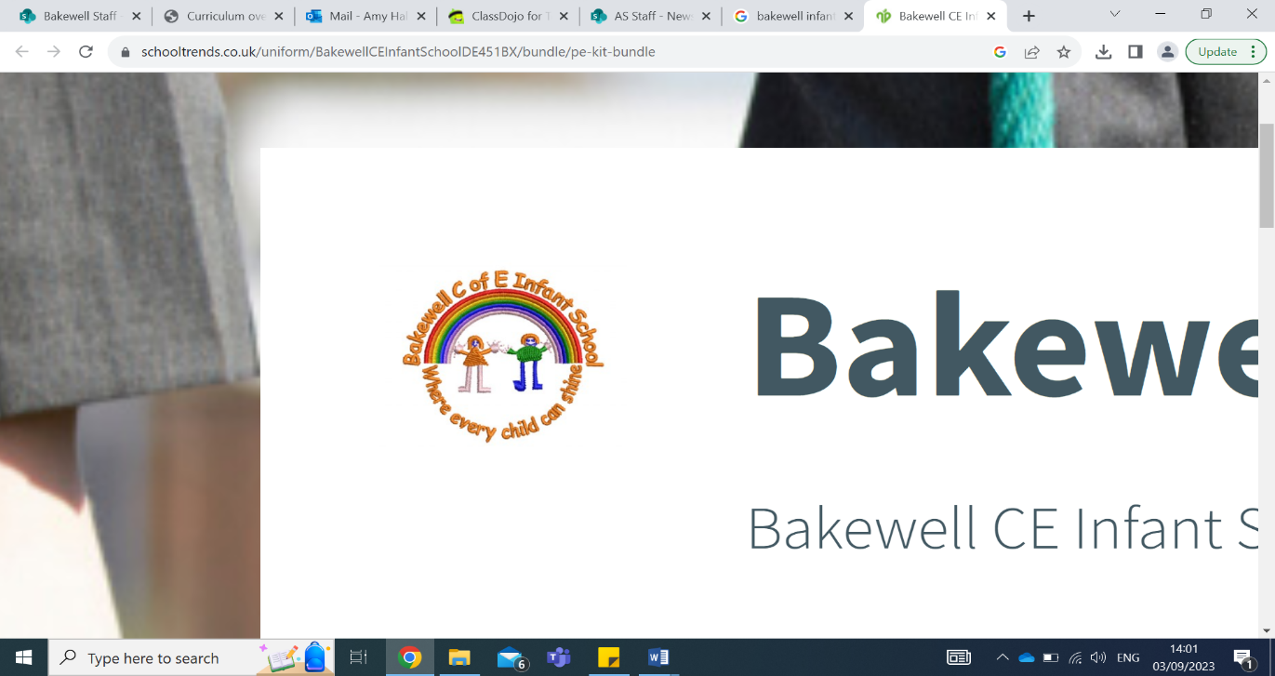
Diary dates:
23rd– 29th September afterschool- Book Fair
14th October – EYFS children flu jabs.
W/C 20th October TBC– Harvest Festival 2pm at the Parish Church – all invited
9st October – School Photos (Individual)
21nd & 23th October – Parents evening
24th October – Last day of term
Reminders:
Please make sure your child brings their book bag to school every day with their reading books and diary to school once we set them up and give them out. Your child will have 1 reading book per week.
Please label all your clothes and water bottles.
Remember to bring a water bottle in every day full of water only.

Scurrying
Pranced
Bleated
Frolicked
Dozing
Furious
Magnificent
Enormous
Gigantic
Chuckled
Plodded
Trembled
Clattered
Gathering
Peeping
Fabulous
Key learning this half term:
Welcome to EYFS at Bakewell C of E Infant School! We have loved getting to know all of the children this week. Thank you for your patience and support at drop off and pick up, as we continue to get to know yourselves and the children.
This term in Wombat Class we are kicking off the year with our ‘Once Upon a Time’ topic. The children have already loved using the small world tray to retell classic stories.
In Maths this term we are learning looking at matching, sorting, patterns and numbers up to 5. We will be learning to match and sort a variety of objects as well count and recognise quantities up to 5.
In Literacy, we are exploring different traditional stories as well as beginning to hold our pencils using a tri-pod grip. We will follow the scheme Little Wandle for phonics, and will apply some letter sounds and names in our literacy lessons.
This term is all about allowing the children to settle in and feel comfortable in their new environment. We will provide lots of opportunities to role play and share stories with all our new friends to build up our confidence and develop key communication skills.

Mr Allen’s recommended read:

The Giggle Pigs by Leonie Lord.
I really like this book because it is really silly and funny!

Wombats Autumn Term 1 2025 Newsletter
Our class texts with new vocab:

