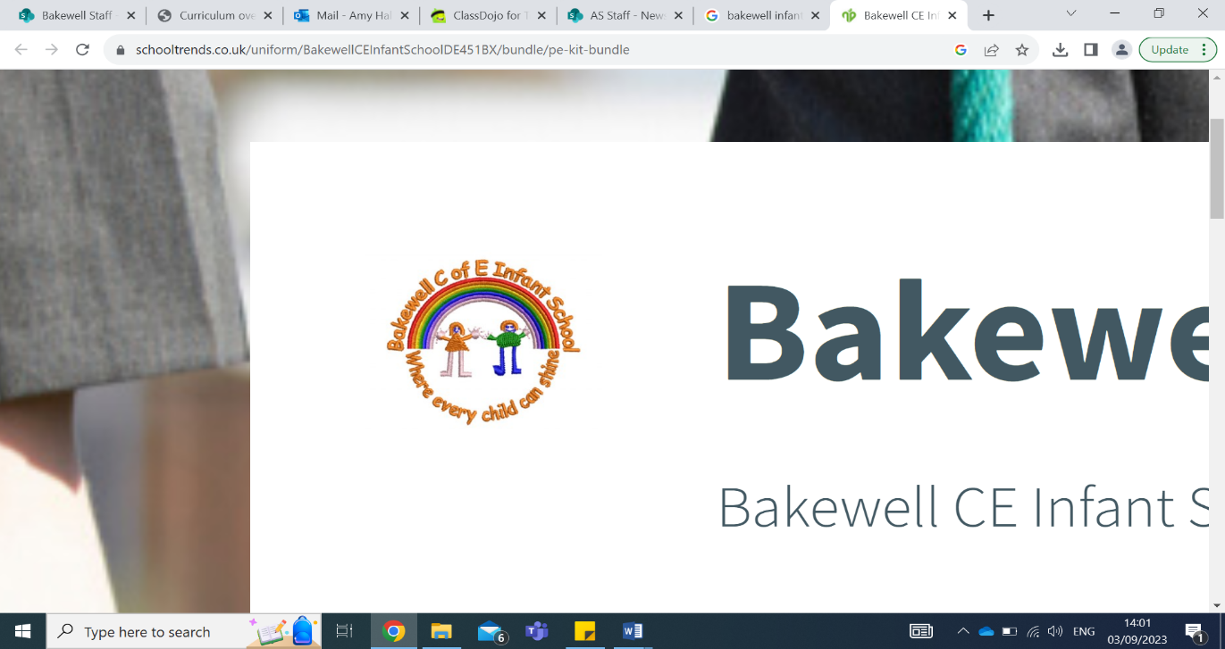
Diary dates:
Tues 14th Jan – PCO visiting school to chat to children at playtime (voluntary)
Tues 21st Jan - KS1 Sports at ARC leisure
Weds 29th Jan - KS1 National Space Centre Visit
3-9th Feb: Children’s Mental Health Week
Tues 11th Feb – Safer Internet Day
Fri 14th Feb – Last Day of Term. Celebration Assembly 2:30pm.

Reminders:
PE days are Monday and Friday.
Homework is sent out on Wednesday, to be returned on Tuesday.
Please record home reading in your child’s reading record.
Please ensure your child has a water bottle in school.

Mrs Holanda’s recommended read:
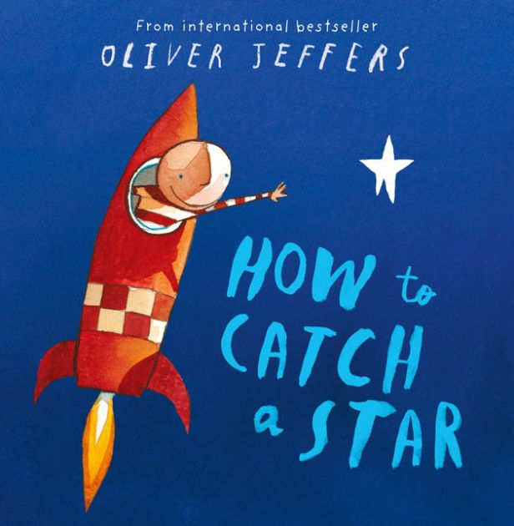
A little boy wants a star of his own and goes on a quest to find one…

Key learning this half term:
This term our topic is Space. We are looking forward to our trip to the Space Centre and discovering all about how humans travel to space!
In Year 1 phonics we will continue to use Little Wandle to ensure our children can read fluently and with prosody and understanding. This term we will continue learning phase 5 sounds. Your child will receive their new Little Wandle reading book on Thursday or Friday. Please encourage your child to read at home with you - if they do this 3 times per week, they will receive dojo points! In Year 2 spelling we will be revising our bridge to spelling unit to prepare us to use phonics to spell new words.
In Writing we will be continuing to practice writing accurate sentences, applying our learning to writing instructions and non-fiction reports.
In Maths, Year 1s will be learning how to measure height and length, and consolidating adding and subtracting within 20. Year 2s will be learning how to measure mass and temperature, read pictograms and consolidate the multiplying and dividing by 2,5, and 10.
In Geography we will be learning about physical and human geography within the local area. In History we will learn about Neil Armstrong and Tim Peake, and compare how space travel has changed.
In DT, we will be creating Ferris wheels. In Music we will be learning about how music can tell a story.
In Computing we will be programming robot algorithms.
In PE we will learning skills in gymnastics.
In PSHE we will be learning about our dream and goals. In RE we will be learning about what Muslims believe.
Beavers Spring 1 2025 Newsletter
Our class texts…


