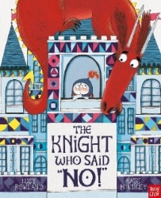
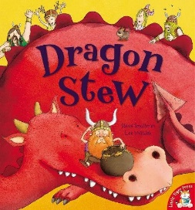
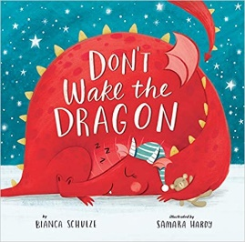
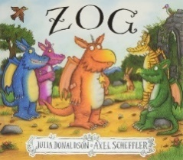
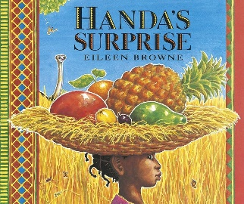
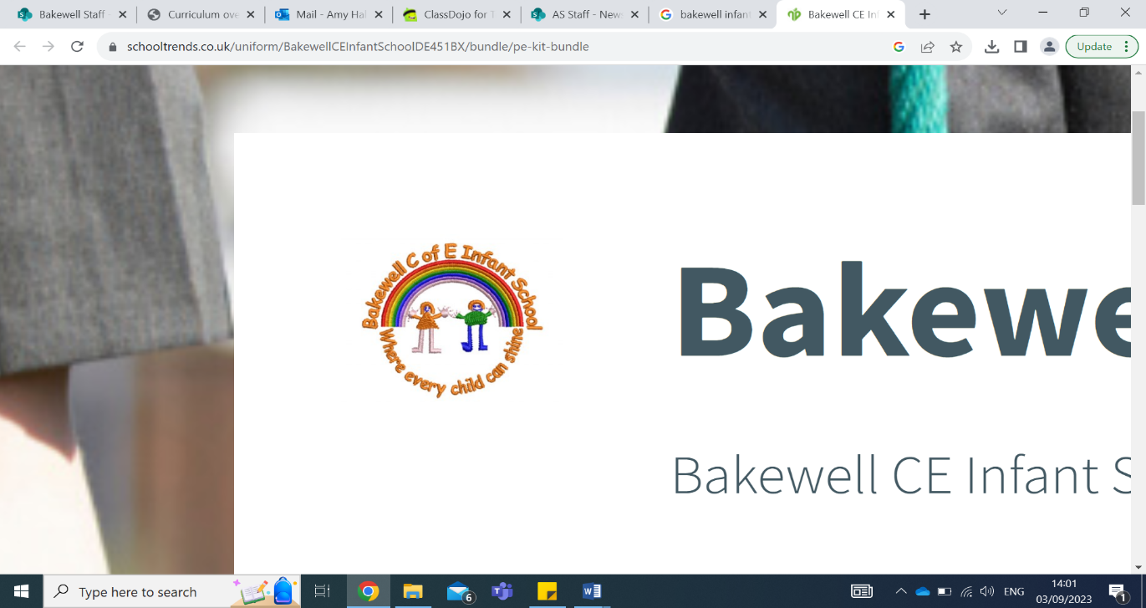
Hollered
Suggested
Amused
Collapsed
Quest
Expert
Capture
Exclaimed
Soothing
Triumph
Swooping
Prickly
Clenched
Uncertain
Impress
Rascally
Entire
Politely
Jiggle
Diary dates:
27th January – EYFS Phonics Workshop 3:15 – 3:45pm
29th January- Chinese New Year
WC 3rd February – Children’s Mental Health Week
11th February – Safer Internet Day
14th February- last day of term – celebration assembly 2:30pm.

Reminders:
Please make sure your child brings their book bag to school every day with their reading books and diary to school.
Please try and read 3x a week at home. This can be any book.
Please label all your clothes and water bottles.
Remember to bring a water bottle in every day full of water.

Key learning this half term:
This term in Otters Class we are exploring the topic ‘Don’t Wake the Dragon’.
In Maths this term we are learning to count to 10 forwards and backwards. We will also learn name positions and understand ordinal numbers. Towards the end of the term we will learn to combine two sets of numbers up to 10.
In Literacy, we are exploring different ‘Don’t Wake the Dragon’ texts. We will be focusing more on correct letter formation and continue to use a tri-pod grip when writing. We will continue to follow the scheme Little Wandle for phonics, and will apply letter sounds and names in our literacy lessons. We will also begin to write more complex CVCC/CCVC words and listening to middle sounds, such as ‘pink’ and ‘shop’.
This term is all about consolidating those skills from Autumn term and becoming a focused learner – whichever the best way may be for your child to learn. We will be building confidence and teaching the children to risk assess situations themselves. We look forward to visiting Bakewell Library, planting our own bulbs and trying new fruit.

Mrs Hope’s recommended read:

Handa’s Surprise by Eileen Browne.
My favourite part is when the cheeky animals take Handa’s fruit!

Our class texts…
Otters Spring Term 1 - 2025 Newsletter

