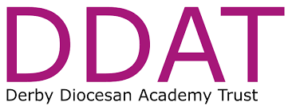

School Music Development Plans

This document includes our trust-wide plans for music in our schools followed by a school-specific plan

DDAT’s vision is to build a better future for all within our academies who in turn will positively impact their communities and we believe that music contributes to the development of this.

Our plans are developed in response to the vision of the National Plan for Music Education:
‘to enable all children and young people to: learn to sing, play an instrument and create music together. have the opportunity to progress their musical interests and talents, including professionally
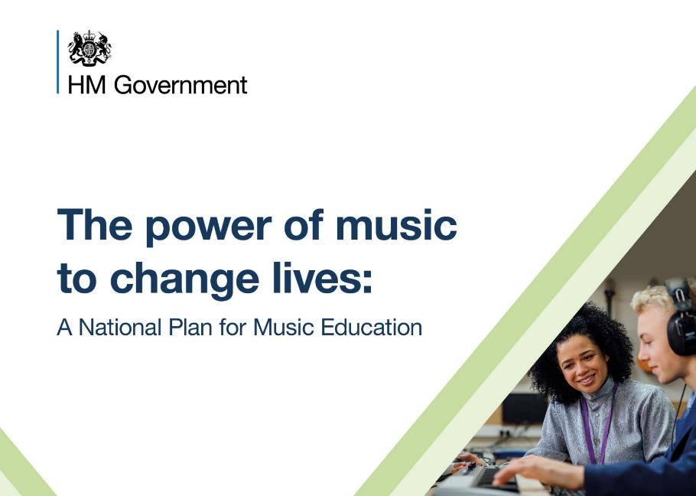

School Music Development Plan for Bakewell C of E Infant School Name of Lead Music Teacher: Sophie Preston Email: spreston@darleychurchtown.derbyshire.sch.uk
School Year 2024-25
DfE features of high-quality school music provision | Current provision | Planned development over the next 2 years | Possible Music Hub Support | Progress/What’s next?
- Curriculum provision | All schools have a music curriculum that compares to the aspirations of the Model Music Curriculum. Music provision in all schools is reviewed Autumn term 2024 | All children in DDAT schools to have 1 hour of music curriculum teaching. School music curriculums to be reviewed by lead music teachers and support offered for those schools who need to develop their offer. | CPD for schools who do not feel confident in their delivery of the music curriculum
- Whole class instrumental teaching | Most schools have whole class instrumental teaching in at least one year group | All schools have whole class instrumental teaching | Music Hub can offer whole class programmes or training for class teachers to deliver whole class instruments such as handbells for example
- Access to lessons across a range of instruments and voice | Most schools offer instrumental teaching on individual instruments or small groups e.g. Rocksteady | All schools have an offer of instrumental teaching either individually or in small groups. Increasing numbers of pupils access these opportunities | Music Hub to signpost accredited teachers and the range of subsidies they offer to support pupils access these
- Develop a school/vocal ensemble | Most schools have a school vocal ensemble that meet regularly | DDAT explores opportunities for combined singing event | Support from Hub Singing Team
- Develop a school ensemble/band/group | Most schools have an instrumental group that make music beyond their whole class lessons | All schools to offer instrumental ensemble opportunities | Music Hub can support with the setting up of instrumental ensembles
- Provide space for rehearsals and individual practice | Most schools have an area where individual and small group teaching can take place | All schools have an identified area where pupils can practice their instruments
- Develop a termly performance | All schools have at least one performance per year | All schools have more than one performance opportunity in the year
- Provide opportunities to enjoy live performances at least once a year | Most schools enable pupils to hear live music-making | DDAT builds a record of approved live musicians | Hub to make recommendations

Trust-specific requirements | Current provision | Planned development over the next 2 years | Possible Music Hub Support | Progress/What’s next?
Music Development Plan and summary | Some schools have created their Plan with clear targets for development | All schools to have created a Plan with opportunities for review built in. They will also have published a summary document, as requested by the DfE | Curriculum and Lead School support available
Professional Development | Trust-wide music network meetings take place twice a year | More music leads attend network meetings

School Music Development Plan for Bakewell C of E Infant School
Name of Lead Music Teacher: Sophie Preston Email: spreston@darleychurchtown.derbyshire.sch.uk
School Year 2024-25
DfE features of high-quality school music provision | Current provision | Planned development over the next 2 years | Possible Music Hub Support | Progress/What’s next?
- Curriculum provision | Music is timetabled for 1 hour in KS1 and 30 minutes for EYFS.  The school has accessed wider opportunities over the past 4 years however, it has been decided that in 2024-2025, the staff will deliver the music curriculum.  The school uses Charanga as its core scheme with adaptations/additions.  It is recognised that Charanga is a good scheme which covers the 4 key areas of music, as stated in the Model Music Curriculum, Singing, Performing, Composing/Improvising and Listening but relies on staff making adaptations to ensure clear progression/coverage.  The music lead has an understanding of the building blocks of music learning and has attended Charanga online training for the revised curriculum (Sept ’23)  A long term music curriculum plan has been established across the partnership of schools.  The music curriculum is established in EYFS and KS1 and adults have the skills and knowledge to deliver this confidently.  Further opportunities are provided for pupils to experience singing for example singing assemblies take place twice a week. Hymns/songs are chosen to support the school’s assembly themes/focus value.  EYFS enjoy weekly singing sessions of 30 mins with piano accompaniment singing a range of topic themed songs and songs of their own choosing.  The school has a range of untuned percussion instruments.  Charanga builds in music from a wide variety of musical styles, genres including a diverse repertoire from across the world to listen to and appraise.  Charanaga has the facility to use technology to create music.  Children are encouraged to record themselves singing, playing and making music and play it back to help with self-evaluation (use of ipads) | Music lead to look for opportunities to utilise other resources to support the delivery of music.  Further opportunities for composition, recording and playing back/evaluation.  Establish a consistent/progressive approach to notation/rhythm (with reference to the Derbyshire music partnership notation).  Provide further opportunities for listening/appraising music – weekly assembly music to be introduce by Head of School.  Music lead to be working across 3 small schools, sharing expertise and resources.  Develop assessment approaches to support our Matlock and Dales assessment strategy (core knowledge)  Music lead to review resources available to deliver Charanga units. | Support music lead with ensuring there is correct progression of skills at all levels.  Support for ideas with composition/opportunities for wider use of technology
- Whole class instrumental teaching | The school has accessed wider opportunities within the community such as learning about ukulele music and singing with the ukulele group at the local community centre.  It has been decided that in 2024-2025, the staff will deliver the music curriculum and join in with musical community events wherever possible.  The music lead was provided with a music plan from wider opps. The musical skills document provided fed into our long term curriculum plan.  Children with SEND have been able to access the programme (adaptations to include simpler rhythms, visual cues) | Consult pupils/parents on further opportunities for learning an instrument.  Provide further opportunities to play an instrument e.g. whole class handbells, recorders. | Music hub to provide ideas/support for teachers in delivering whole class instrument teaching.
- Access to lessons across a range of instruments and voice |  | Consult pupils/parents on further opportunities for learning an instrument and explore possible peripatetic music tuition (Parent survey).  Look into using PP funding to support tuition  Provide further opportunities to learn an instrument e.g. recorder
- Develop a school/vocal ensemble | EYFS and KS1 children perform songs to their peers and parents/carers as part of their nativity performance and as part of end of term Celebration assemblies each half term.  Children in all year groups have performed to the local community as part of Christmas celebrations at the local community centre.  During the Easter service,  KS1 and EYFS children perform songs to their parents and community at the local church.  At all events, children are encouraged to sing with an awareness of dynamics and style. | Music lead to be working across 3 small school, sharing expertise, resources and to align the curriculum.
- Develop a school ensemble/band/group | A range of styles has been studied including those from other cultures. This is built into the curriculum constituting the performance element alongside the Charanga units.  EYFS and KS1 children work towards a performance in the church and at the school at Christmas for parents/the community.  The children learn simple rhythms and start by learning basic tunes. By the end of the block of session children are performing tunes that include several children playing together and use a range of rhythms. | Expand the range of instruments available to learn.
- Provide space for rehearsals and individual practice | The school hall or individual classrooms provide space for rehearsals and individual practice.  Pupils do not currently take any musical instruments home with them.  Instruments are stored together in a designated cupboard for this purpose. | Consult pupils/parents on further opportunities for learning an instrument and explore possible peripatetic music tuition.  Look into using PP funding to support tuition.
- Develop a termly performance | EYFS and KS1 children perform songs to parents and the community at The Harvest Festival, Christmas and Easter as part of church services. Songs are also performed at end of term Celebration assemblies when parents and carers are invited.  EYFS and KS1 have enjoyed performing Christmas songs at the local community centre at Christmas time. | Continue to strengthen links with the local junior school as well as partnership schools to widen opportunities to see performances.
- Provide opportunities to enjoy live performances at least once a year | All children go to watch the pantomime annually. This year we are going to the historic venue - Buxton Opera House.  A part of some church events, an organist performs.  Children in EYFS and KS1 have attended the local community centre to watch a ukulele group perform.  The infant school children go the junior school to watch the junior children perform their Christmas play. | Continue to strengthen links with the local junior school and partnership schools to widen opportunities for pupils/teachers to perform for us.  Contact parents to see if there are any musicians available to perform.

