6th June 2024
Relationship and Sex Education consultation

Dear parents/carers,

I hope this letter finds you safe and well.

Many thanks for taking time to respond to the short survey which we sent last term regarding our school’s curriculum for sex education.

You may recall that sex education within primary schools is non-statutory so we are further consulting with parents to ensure our curriculum is clearly defined, age-appropriate and sensitive.

A summary of the responses we have received are available below:

- 75% of the parents who responded to our survey stated that they would consent for their children, ‘to be taught sex education, in a sensitive and age-appropriate context’.
- The majority of respondents felt comfortable talking to their children about growing up, relationships and sex education.
- Most respondents said that they had some understanding of the school’s current policy (with the average response being 3 out of 5).

Now that we have completed our consultation, we are aiming to teach RSE from 10th June 2024. If you would like to remove your child from an individual lesson or all lessons please let myself or the class teacher know.

Once again, I would like to say thank you for taking time to complete our RSE survey

Many thanks,

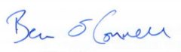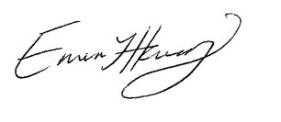

Ben O’Connell and Emma-Jane Harry

